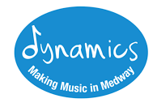
MMA MUSIC CENTRE TERM DATES 2017-18

TERM 1
September 16th – October 14th 2017

TERM 2
November 4th – December 9th 2017
NO MUSIC CENTRE ON 25TH NOVEMBER
December 9th – End of Term Concert

TERM 3
January 13th – February 3rd 2018

TERM 4
February 24th – March 24th 2018

TERM 5
April 21st – May 19th 2018

TERM 6
June 9th – July 7th 2018
July 7th – End of Year Concert

