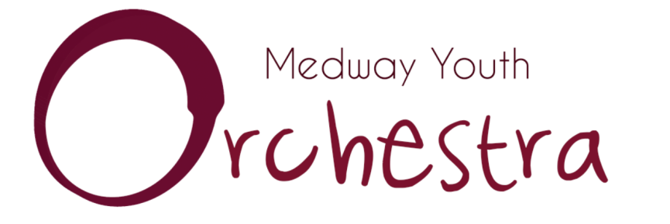
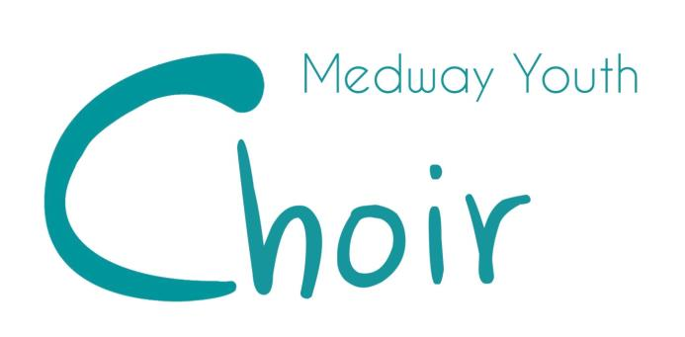

Dates for 2017-2018

SEPTEMBER
16th and 17th – Orchestra
23rd and 24th – Choir

NOVEMBER
26th – Choir

DECEMBER
3rd – Orchestra
10th – Choir and Orchestra dress rehearsal
10th – JOINT CONCERT

FEBRUARY
12th to 14th – Orchestra
14th – 16th – Choir

APRIL
8th – Choir and Orchestra

JUNE
30th – Choir

JULY
1st – Choir
6th – Choir and Orchestra dress rehearsal
6th – JOINT CONCERT

